Hotel Revenue Analysis and Business Insights for AtliQ Grands

📖 Introduction
AtliQ Grands is a well-established hotel in India with over 20 years of experience in the hospitality industry. Recently, the company has been facing a decline in revenue and market share due to rising competition and less effective decision-making.
To address this, the organization aims to adopt a data-driven approach using Business Intelligence. In this project, given hotels data is analysed using Excel to create key performance metrics and an interactive dashboard.
Unlike focusing on a single segment, this project provides a comprehensive view of business performance by analysing multiple aspects such as revenue trends, occupancy, booking behaviour, and overall operational efficiency. The dashboard is designed to support decision-making across different business perspectives.

⚠️ Problem Statement
AtliQ Grands is experiencing a decline in overall business performance, including revenue and market position. The main challenges include:
- Lack of data-driven decision-making
- Increasing competition in the hotel industry
- Inefficient analysis of business performance
- No dedicated analytics team for insights generation
Because of these issues, the company struggles to clearly understand performance across different business areas such as bookings, occupancy, and revenue trends.

📌 Project Objectives
The primary objective of this project is to leverage data analysis and visualization techniques to evaluate overall hotel business performance and support informed decision-making.
- Create key performance metrics from the given dataset
- Develop an interactive dashboard based on stakeholder requirements
- Analyze data to generate insights across multiple business views
- Support strategic and operational decision-making through data-driven insights
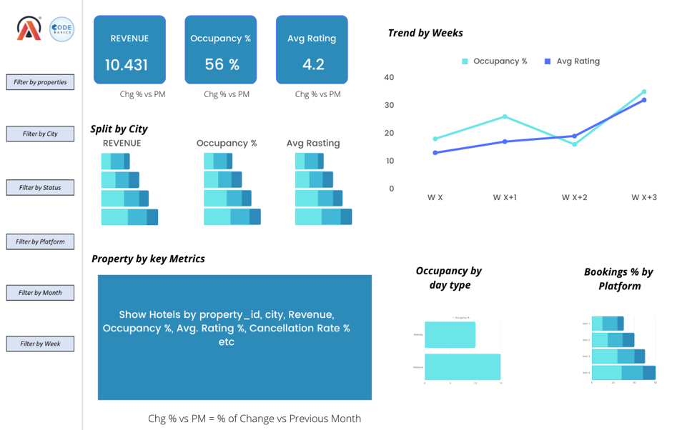
PREVIEW DASHBOARD

📂 Data Source and Structure
The dataset for this project consists of multiple CSV files provided for analysis and dashboard development:
- 2 Fact Tables – Contain transactional data related to hotel operations
- 3 Dimension Tables – Include descriptive data such as hotel details, dates, and other rooms categorical information
- 1 Metadata File – Provides detailed information about each column in the dataset
- 1 Mock-up Dashboard Image – Represents the expected layout and design of the final dashboard
- 1 Metrics File – Defines the key metrics that need to be created for analysis
This structured data enables comprehensive analysis from multiple business perspectives.
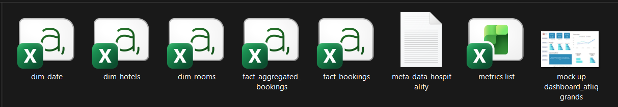
DATA FILES

🔗 Data Modelling
Data modelling was performed to establish relationships between fact and dimension tables. By connecting the tables using common columns (keys), a structured data model was created.
This approach helps to:
- Improve data consistency and accuracy
- Enable efficient data analysis across multiple tables
- Increase flexibility while creating calculations and dashboards
The relationships allow seamless integration of data, making it easier to generate insights and build interactive visualizations.
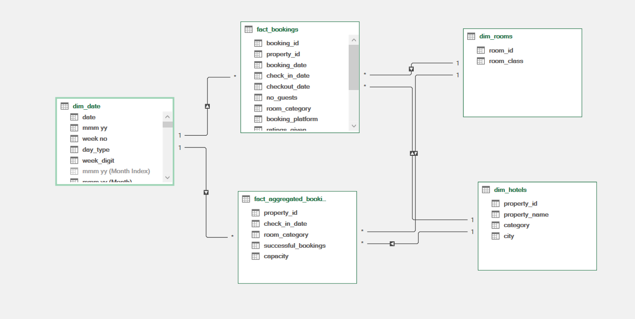
DATA MODEL VIEW

🧹 Data Cleaning and Preprocessing
During the data cleaning and preprocessing stage, necessary steps were taken to ensure data consistency and improve analysis quality.
- Data Type Correction:
Some columns were converted to appropriate data types to ensure efficiency and accurate calculations.
- Handling Data Inconsistency:
The fact booking table contained data for 4 months, while the date dimension table included only 3 months.
To maintain consistency in the data model, the extra one-month data was filtered out from the booking table.
- Handling Missing Values:
Missing values in one of the columns were handled by replacing them with the average value, ensuring minimal impact on analysis.
- Feature Engineering:
A new column, Week Number, was created to support proper sorting and better time-based analysis.
Overall, the dataset was relatively clean, and no major additional preprocessing steps were required beyond these adjustments.

📊 Dashboard Architecture
The dashboard is designed to provide a comprehensive view of overall business performance through five key analytical views, each focusing on a specific aspect of the hotel operations.
1. Executive Overview
This view provides a high-level summary of key business performance indicators, including:
- Revenue, Occupancy %, and Average Rating
- Year-over-Year (YoY) % changes for key metrics
- Key metrics by property (tabular view)
- Week-over-Week (WoW) revenue trend chart
- Interactive filters for dynamic analysis
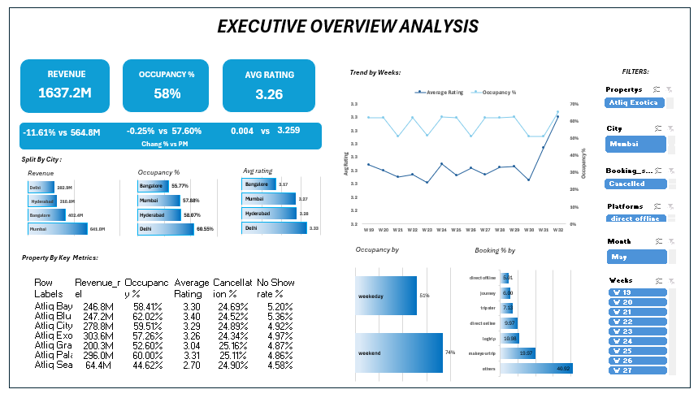

2. Revenue Dashboard
This view focuses on revenue-related analysis, including:
- Revenue-based KPIs
- Revenue trends and performance charts
- Insights into revenue distribution across different dimensions
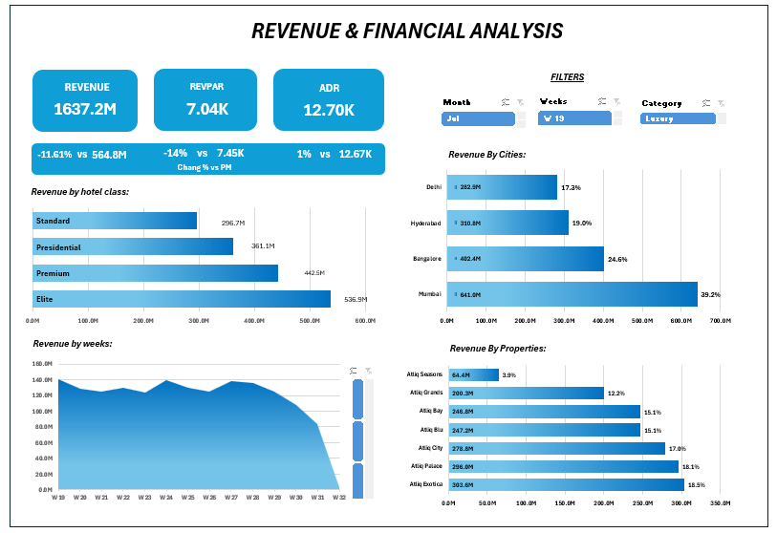

3. Occupancy and Capacity Analysis
This view analyses how efficiently hotel capacity is being utilized:
- Occupancy rates
- Capacity utilization metrics
- Comparative analysis across properties or time periods
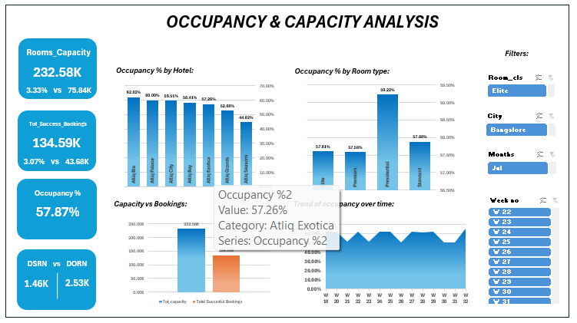

4. Customer Behaviour Analysis
This view provides insights into customer booking patterns and behavior:
- Booking trends
- Customer segmentation insights
- Analysis across different booking platforms or categories
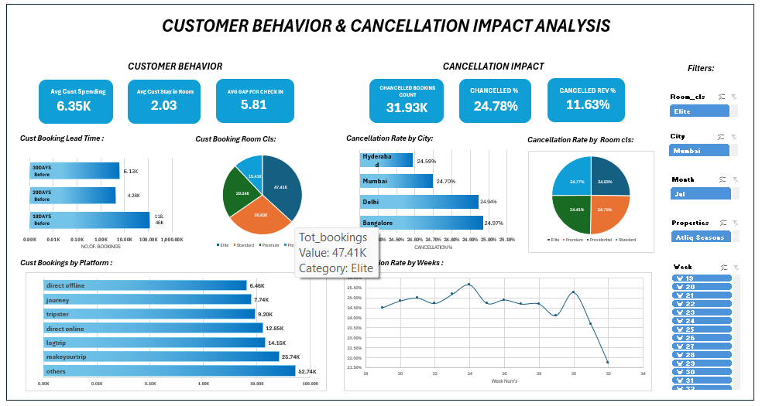

5. Customer Experience Dashboard
This view focuses on customer satisfaction and feedback:
- Ratings and review analysis
- Trends in customer experience
- Identification of areas for service improvement
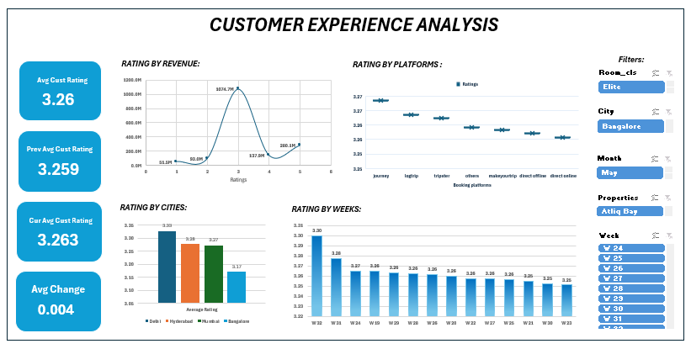
Key Business Insights
1.Executive Overview – Insights
- Revenue declined by 11.61%, while occupancy (~58%) and ratings (~3.26) remained stable.
👉 Indicates issue with pricing or revenue strategy, not demand.
- Mumbai is the top revenue contributor, while Delhi has highest occupancy but lowest revenue.
👉 Suggests pricing imbalance across cities.
- Atliq Seasons is underperforming in both revenue and occupancy.
👉 Needs improvement or strategic review.
- Weekend occupancy (74%) is much higher than weekdays (51%).
👉 Shows weak weekday demand.

🚀 Recommendations
- Optimize pricing (ADR) to fix revenue drop
- Increase weekday demand (offers, corporate bookings)
- Adjust city-level pricing strategies
- Improve or review underperforming properties
- Enhance customer experience to boost ratings
- Analyze recent revenue drop trend and apply seasonal strategies

2.Revenue Dashboard – Insights
- RevPAR declined by 14%, while ADR increased by 1%.
👉 Indicates lower revenue efficiency, possibly due to reduced occupancy or ineffective pricing/discount strategy.
- Elite category generates the highest revenue (~536.9M), followed by Premium, while Standard is the lowest (~296.7M).
👉 Suggests lower demand or weaker value perception in Standard category.
- Weekly revenue trend shows fluctuations with a sharp drop in Week 32.
👉 Indicates possible seasonal drop or external factors affecting demand.
- City and property insights remain consistent with earlier findings (Mumbai leading, some properties underperforming).
🚀 Recommendations
- Improve RevPAR by balancing pricing and occupancy
- Enhance Standard category (better services, pricing, offers)
- Investigate Week 32 drop and apply corrective strategies
- Optimize discount strategies to avoid revenue loss
- Focus on high-performing categories while improving low-performing ones

3.Occupancy & Capacity Analysis – Insights
- Overall occupancy is ~57.87%, indicating moderate utilization of available capacity.
- Total capacity (232.58K) is much higher than successful bookings (134.59K).
👉 Shows underutilization of available rooms.
- Occupancy by hotel shows variation across properties, with some performing well (~60%+) and others significantly lower (~44%).
👉 Indicates uneven performance across hotels.
- Occupancy by room type:
  - Presidential rooms have highest occupancy (~59%)
  - Other categories (Elite, Premium, Standard) are slightly lower
👉 Higher-end rooms are performing better than expected.
- Trend over time shows fluctuations but no strong growth pattern.
👉 Indicates inconsistent demand.

🚀 Recommendations
- Improve occupancy rates through targeted marketing and better pricing strategies
- Focus on underperforming properties and optimize their operations
- Increase utilization of available capacity (promotions, partnerships, campaigns)
- Boost demand for lower-performing room types through offers or bundling
- Stabilize demand trends using seasonal planning and demand forecasting

4.Customer Behaviour & Cancellation Analysis – Insights
🔹 Customer Behaviour
- Average customer spending is 6.35K, with an average stay of ~2 days.
- Most bookings are made 20–30 days in advance.
👉 Indicates short stay duration and moderate planning window.
- Elite room class has highest bookings (~47%).
👉 Shows preference for higher-value room categories.
- Major bookings come from MakeMyTrip, Logtrip, and Direct Online channels.
👉 Business is highly dependent on online platforms.

🔹 Cancellation Impact
- Total cancellations: 31.93K (24.78%)
- Revenue loss due to cancellations: 11.63%
👉 Significant impact on overall revenue.
- Cancellation rates are similar across cities (~24–25%)
👉 Indicates a system-wide issue, not location-specific.
- Cancellation trend fluctuates, with a sharp drop in recent weeks
👉 Needs further monitoring for consistency.

🚀 Recommendations
- Reduce cancellations by improving booking policies (partial payments, stricter rules)
- Offer incentives for confirmed stays (discounts, loyalty benefits)
- Strengthen high-performing booking platforms
- Encourage longer stays through package deals
- Analyze cancellation reasons to take targeted actions

5.Customer Experience Analysis – Insights
- Average rating is ~3.26, showing moderate customer satisfaction with minimal change over time.
- Ratings vs Revenue shows higher revenue around mid-level ratings (~3–4).
👉 Indicates most bookings come from average satisfaction levels, not excellent experiences.
- City-wise ratings:
  - Delhi has highest ratings (~3.38)
  - Bangalore has lowest (~3.17)
👉 Customer experience varies across cities.
- Platform-wise ratings show slight variation, with some platforms performing better than others.
👉 Indicates inconsistent experience across booking channels.
- Weekly trend shows ratings are stable but slightly declining.
👉 No strong improvement in customer satisfaction.

🚀 Recommendations
- Improve overall service quality to push ratings above 3.5+
- Focus on low-performing cities (e.g., Bangalore)
- Standardize experience across booking platforms
- Collect and act on customer feedback regularly
- Enhance customer engagement and loyalty programs

📌 Conclusion
This project provides a comprehensive analysis of AtliQ Grands’ overall business performance using data-driven insights. The analysis reveals that the decline in revenue is primarily driven by inefficiencies in pricing, high cancellation rates, and uneven performance across cities and properties, rather than a lack of demand.
While occupancy levels remain relatively stable, there is significant scope for improvement in revenue optimization, weekday demand, and customer experience. Additionally, high dependency on specific cities and booking platforms highlights potential business risks.
By implementing better pricing strategies, improving service quality, reducing cancellations, and optimizing underperforming areas, AtliQ Grands can enhance its market position and achieve sustainable growth.

